AI/ML Course Assignment

Linear Algebra, Python, NumPy & OpenCV Image Processing

Submitted By:

Ankit Shrestha

Submitted To:

Samriddha Pathak

Deadline:

8th August 2025

**Table Of Contents**

Question 1: Linear Algebra Fundamentals: 3

Question 2: NumPy Array Manipulation: 7

Question 3: Image Loading and Basic Processing: 11

Question 4: Image Resizing and Geometric Transformations: 13

Question 5: Edge Detection and Blurring Techniques: 16

Question 6: Face Detection Implementation: 19

Question 7: Linear Algebra in Image Processing: 22

Question 8: Integrated Project - Image Analysis Pipeline: 24

# Question 1: Linear Algebra Fundamentals:

Write a Python function that performs the following operations on two matrices A and B:

• Matrix multiplication (A × B):

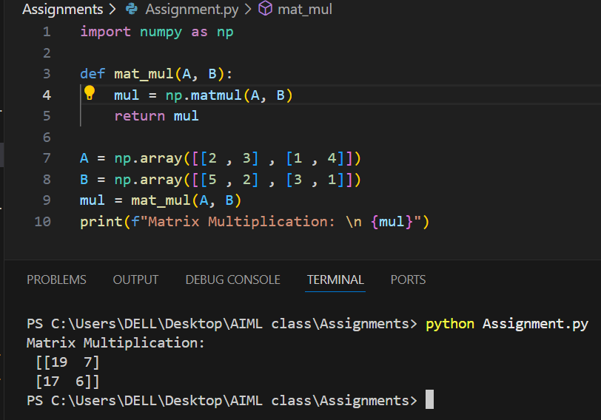

• Element-wise multiplication (A ⊙ B):

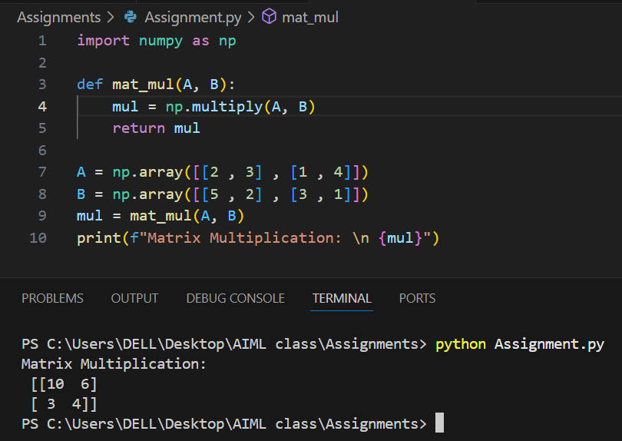

• Calculate the determinant of matrix A:

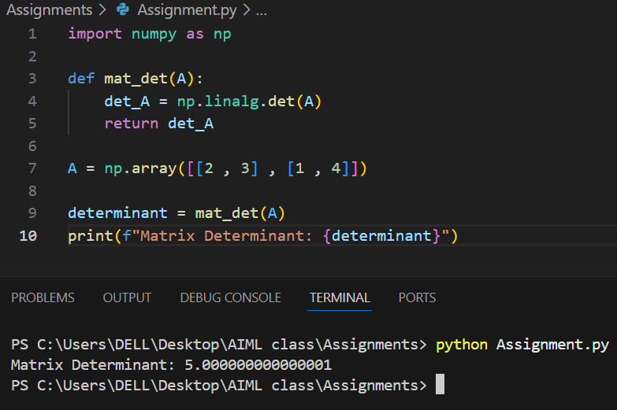

• Find the transpose of matrix B (B^T ):

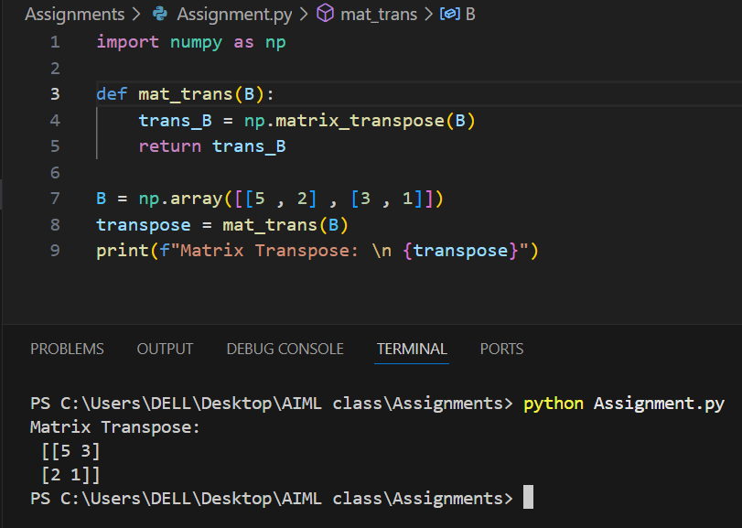

# Question 2: NumPy Array Manipulation:

Create a Python program that:

1. Generates a 6 × 6 matrix filled with random integers between 10 and 100:

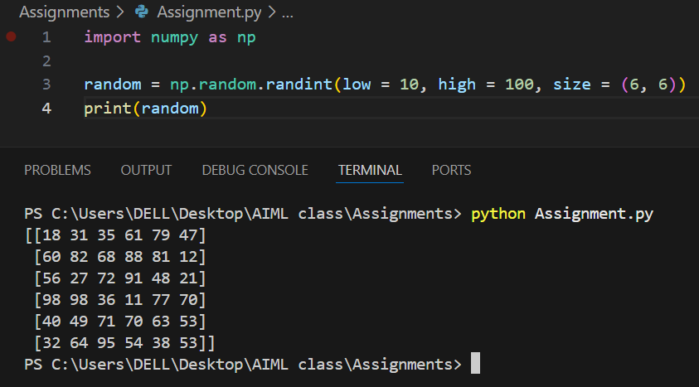

1. Extracts the diagonal elements and stores them in a separate array:

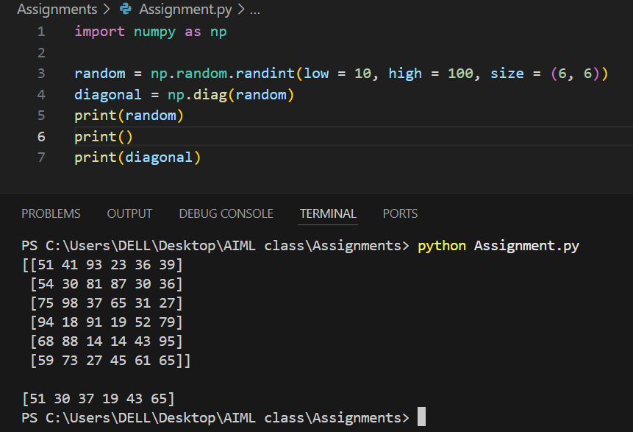

1. Replaces all even numbers in the original matrix with their square roots:

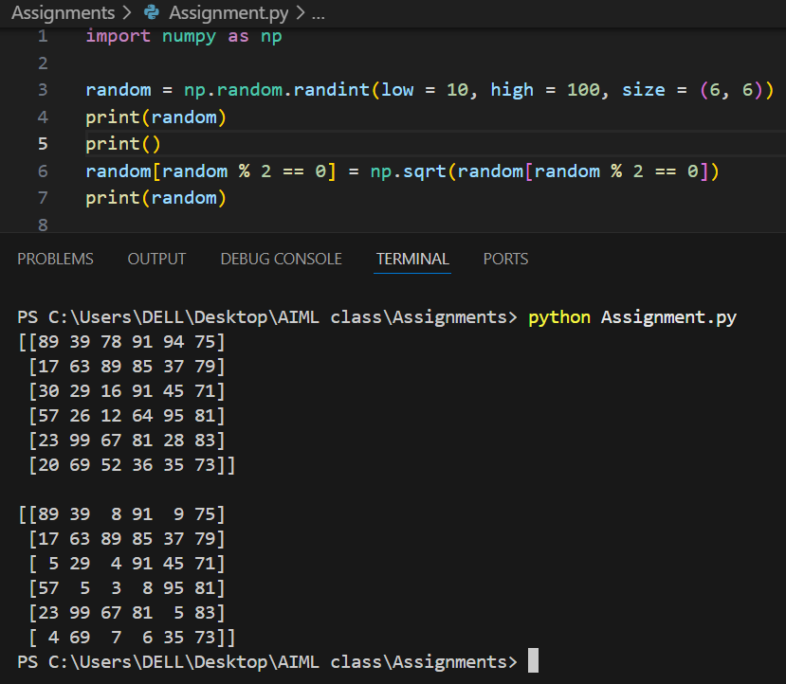

1. Finds the mean, median, and standard deviation of the modified matrix:

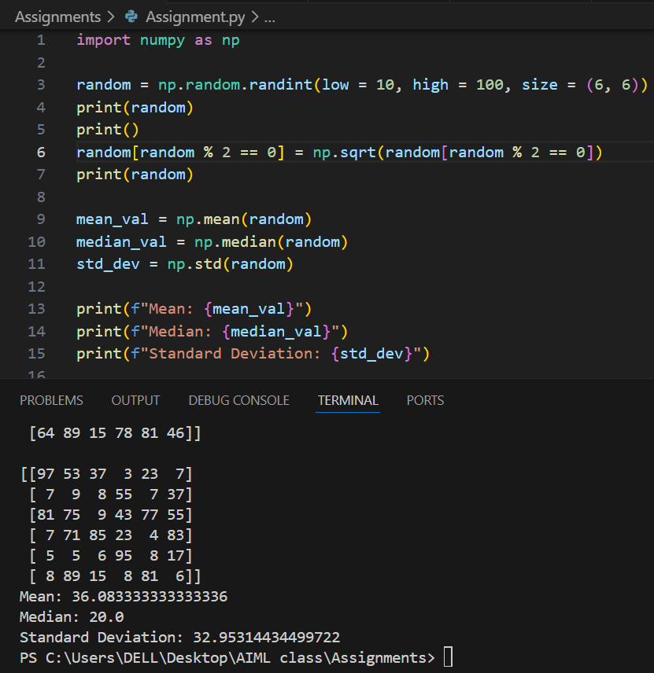

1. Reshapes the matrix into a 4 × 9 matrix:

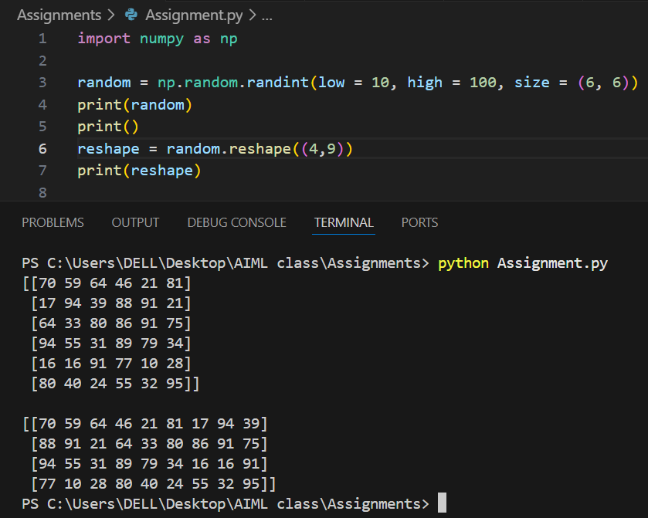

# Question 3: Image Loading and Basic Processing:

Using OpenCV, write a program that:

1. Load a color image from your local system:
2. Converts the image to grayscale using OpenCV functions:
3. Displays both the original and grayscale images side by side:

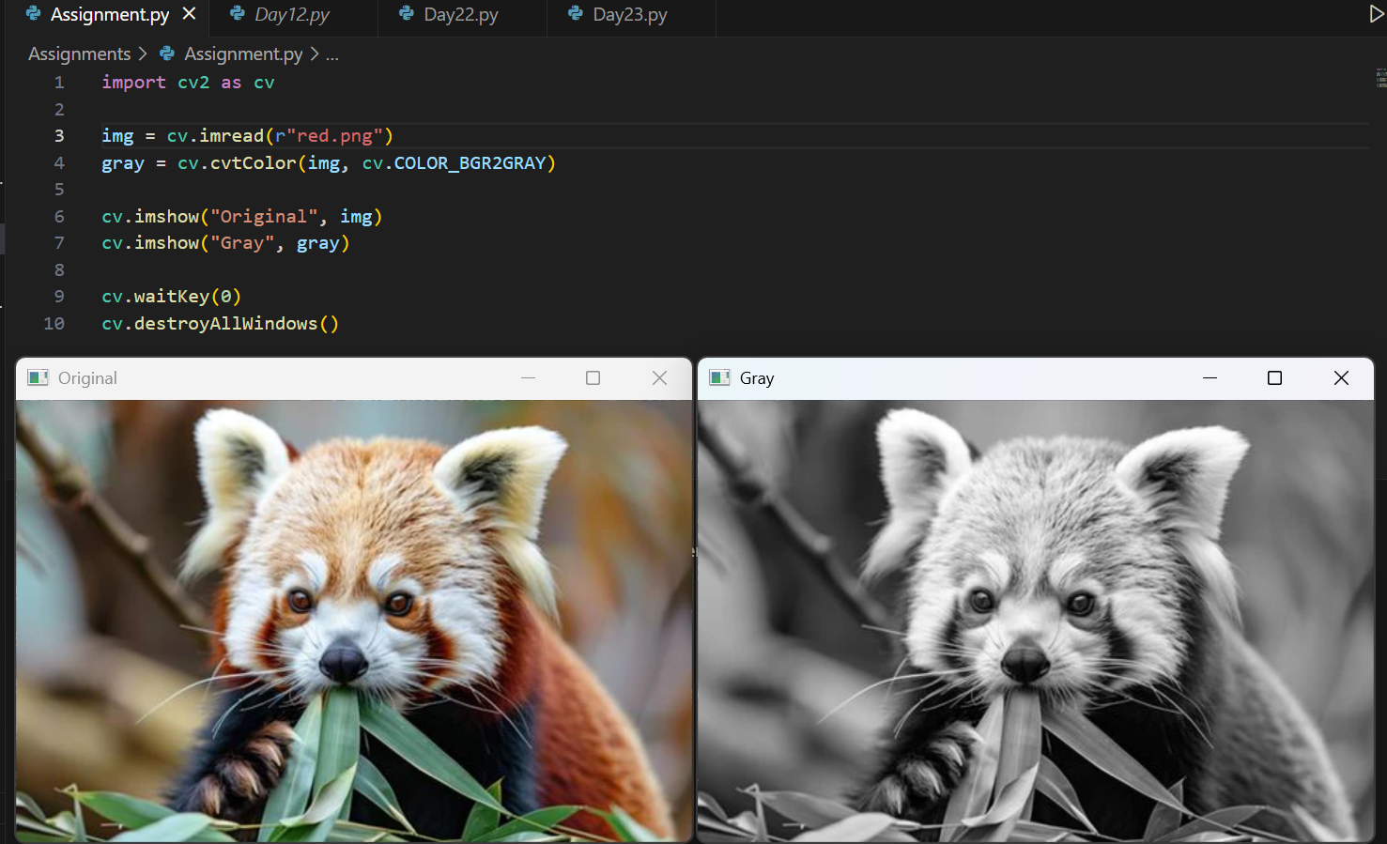

1. Saves the grayscale image with a new filename:

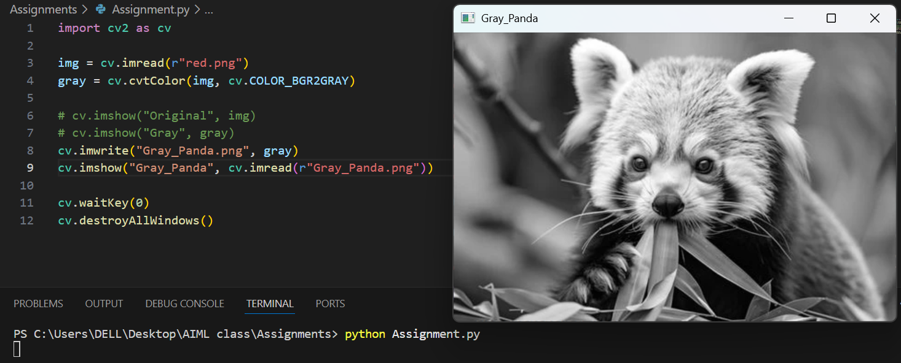

1. Prints the dimensions (height, width, channels) of both images:

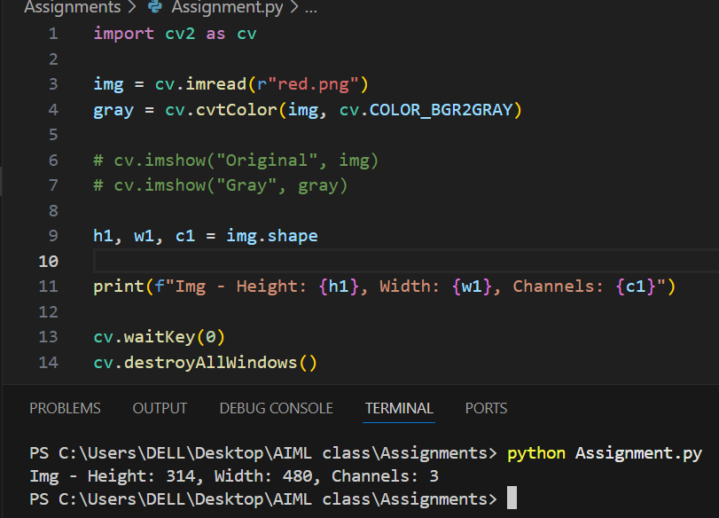

For gray scaled image, there is no color channel so we get an error. To fix this, Channel c is removed with only height and width calculated.

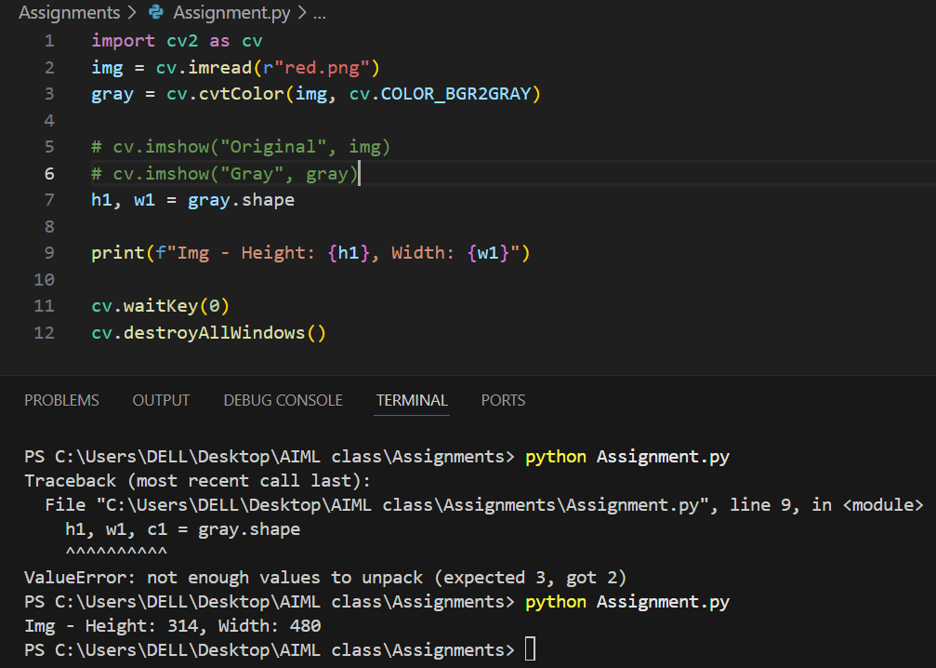

# Question 4: Image Resizing and Geometric Transformations:

1. Resize the image to three different sizes: 50% smaller, 200% larger, and fixed size 300×300 pixels:

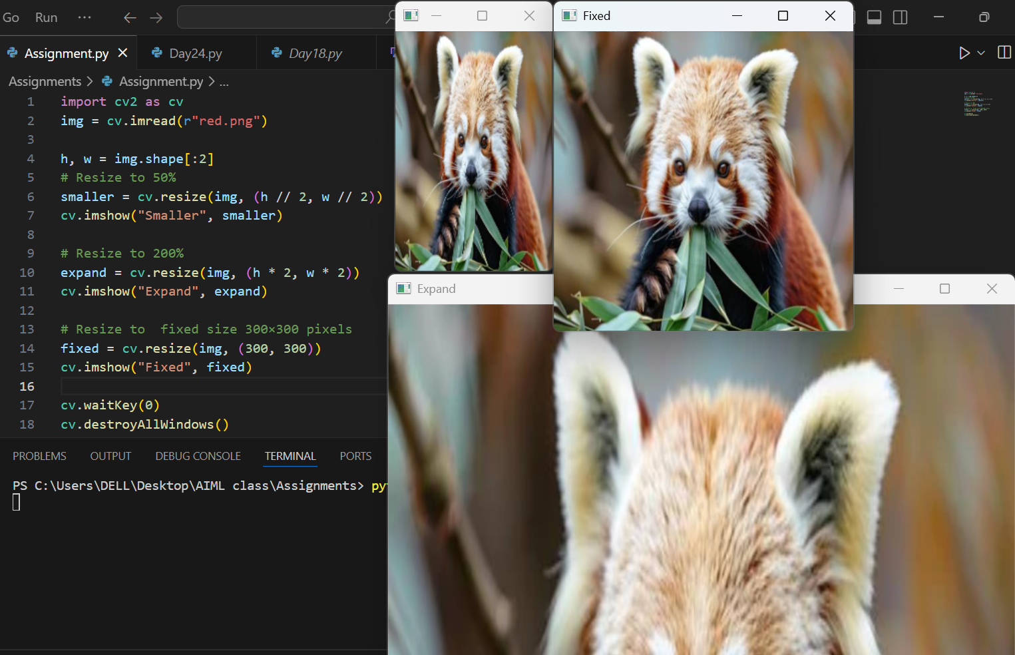

2. For each resized image, calculate and display:

• Original dimensions

• New dimensions

• Scaling factors used

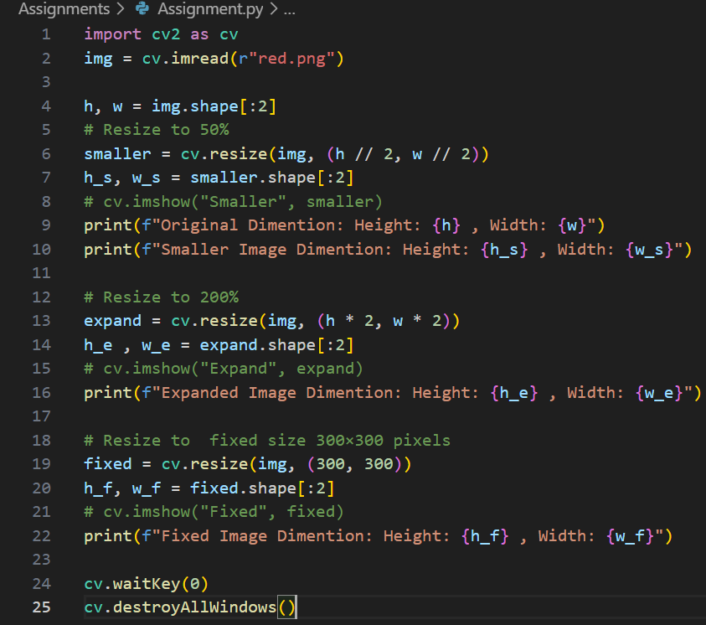

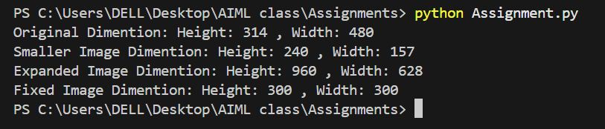

3. Save all resized images with descriptive filenames:

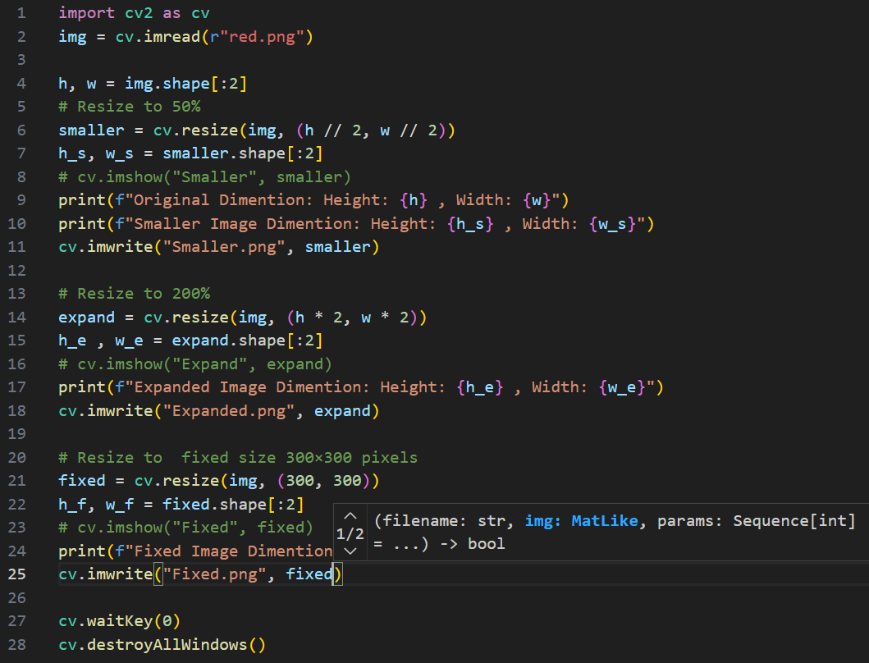

# Question 5: Edge Detection and Blurring Techniques:

Create a comprehensive image filtering program that:

1. Applies three different types of blurring to an input image:

• Gaussian blur (kernel size 15 × 15)

• Average blur (kernel size 10 × 10)

• Median blur (kernel size 9)

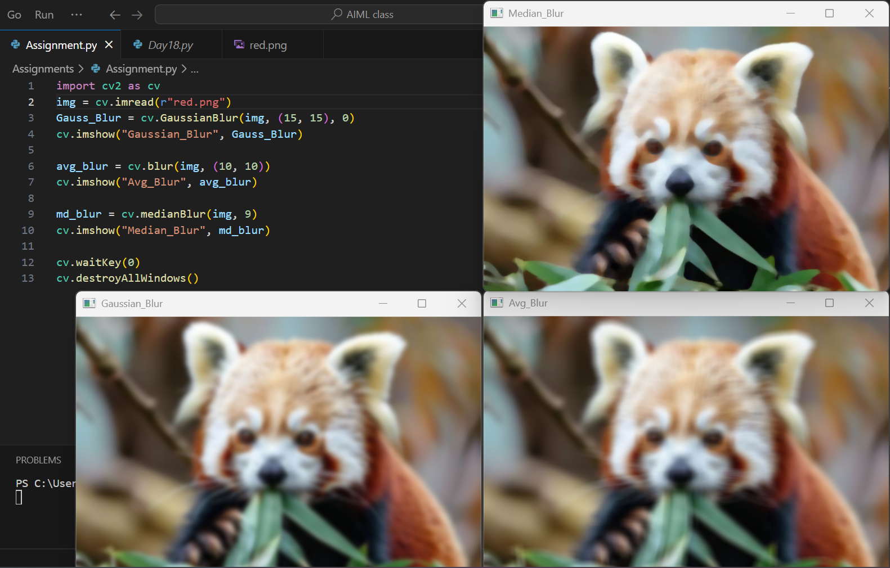

2. Performs edge detection using:

• Canny edge detection

• Sobel edge detection (both X and Y gradients)

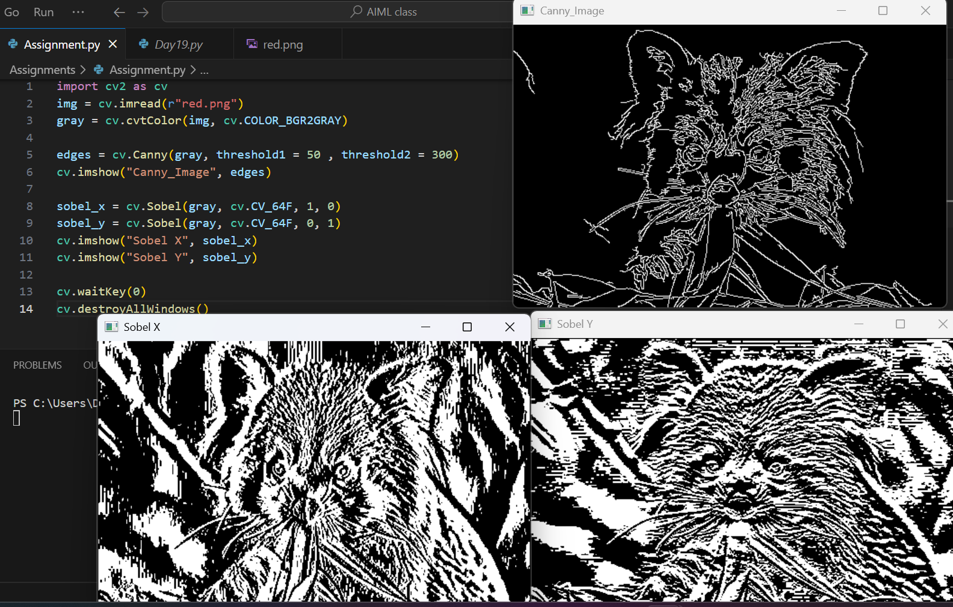

3. Create a combined display showing all results in a grid format:

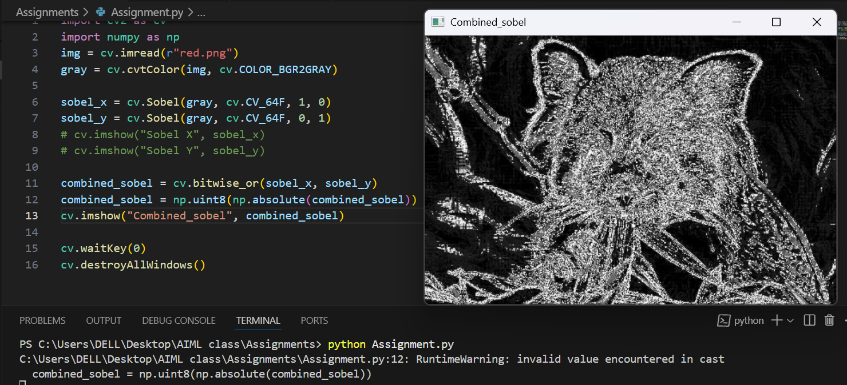

4. Allows the user to adjust blur parameters through command-line arguments:

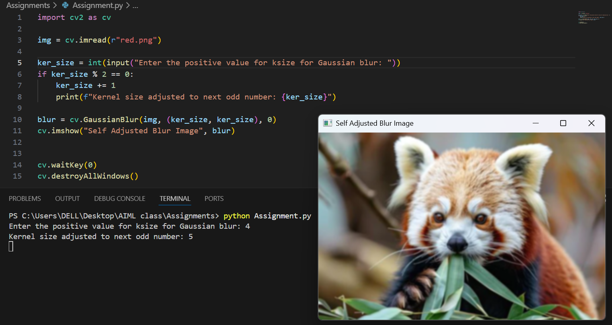

# Question 6: Face Detection Implementation:

Implement a face detection system using Haar cascades that:

1. Load a pre-trained Haar cascade classifier for face detection:

2. Detect faces in both static images and real-time webcam feed:

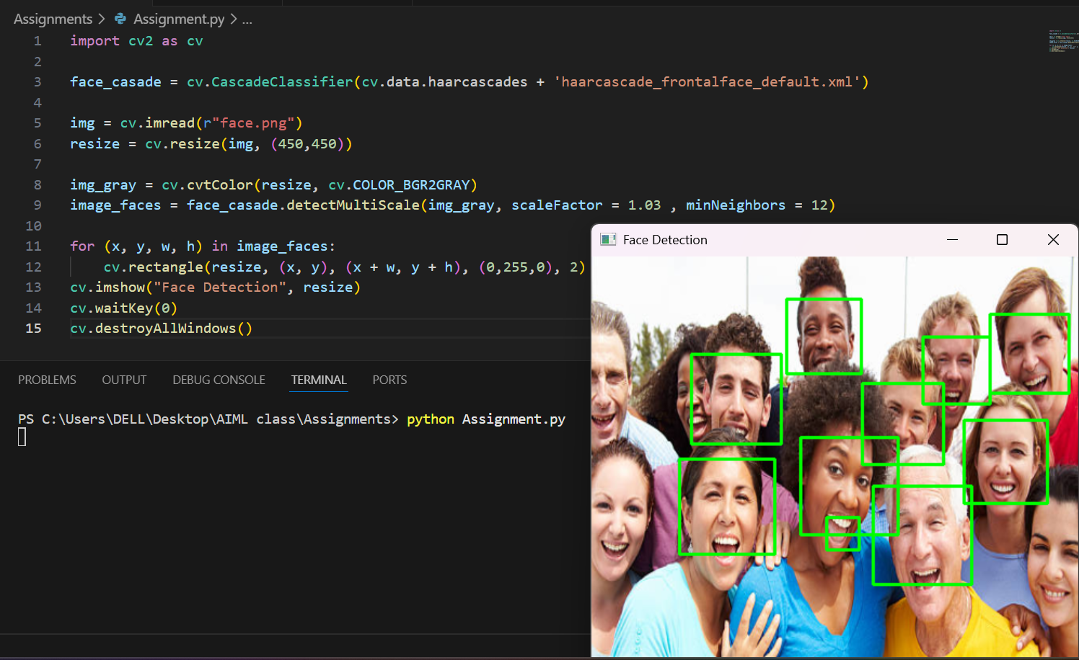

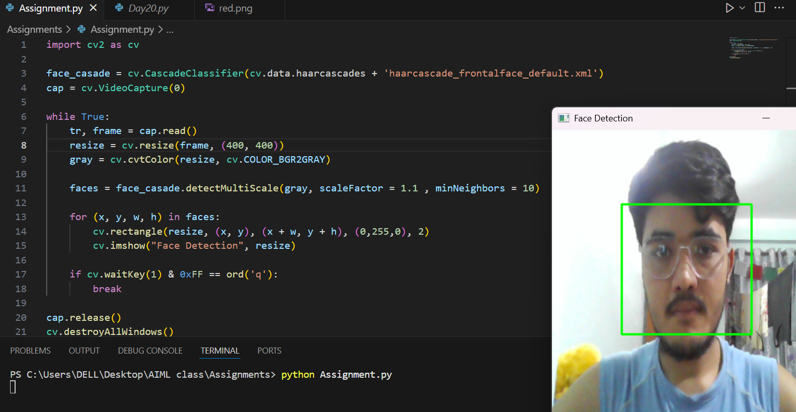

3. Draws bounding rectangles around detected faces with:s

* Different colors for different face sizes (small, medium, large):
* Displays the number of faces detected:

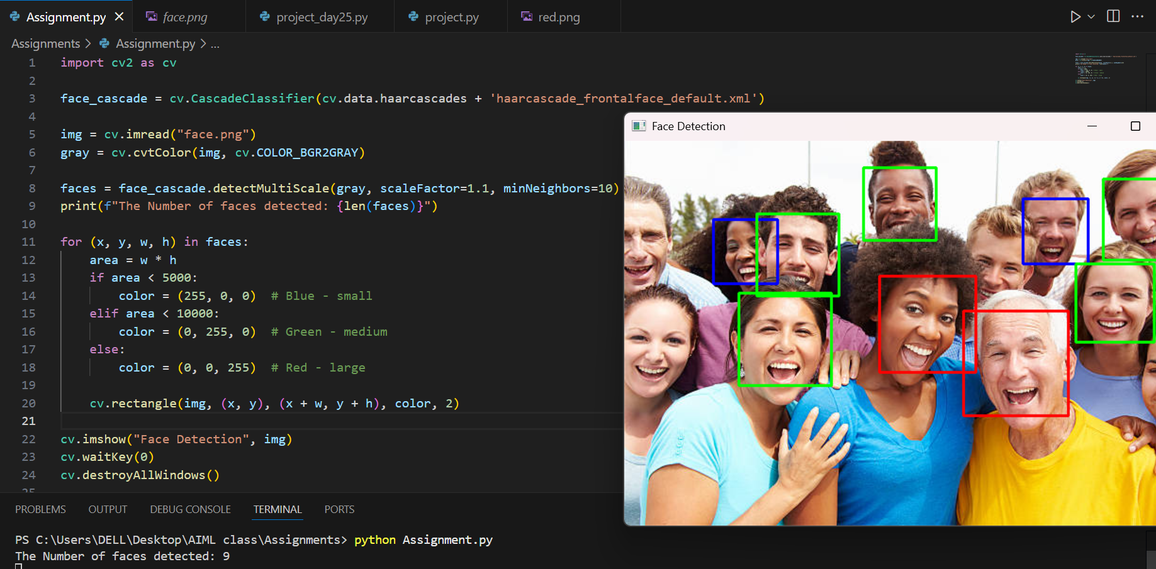

4. Saves images with detected faces marked:

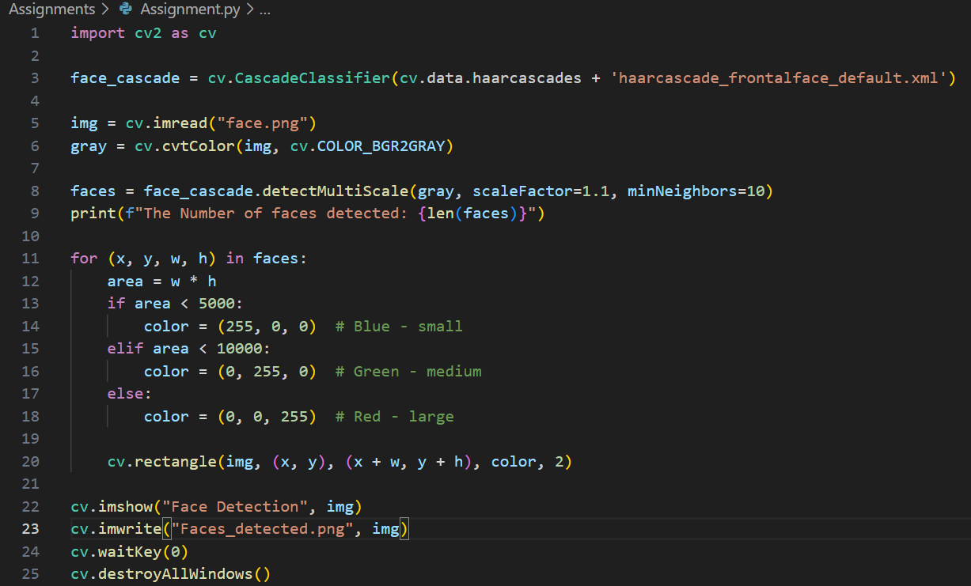

5. Implement confidence thresholding to reduce false positives:

During detecting objects like face, the detector assigns a value between 0-1 which is referred as a confidence score. Here, value closure to 1 represents that the model is confident that the object it detected is likely to be a face and closure to 0 is vice versa. A threshold refers to a certain value set from which the confidence score greater to that value is only shown as a face detected. This is likely practiced to reduce the false positive cases. Unfortunately, Haar Cascades doesn’t provide confidence score, it only returns bounding boxes.

# Question 7: Linear Algebra in Image Processing:

Write a program that demonstrates the application of linear algebra in image processing:

1. Load a color image and convert it to grayscale:

2. Represent the grayscale image as a 2D NumPy array (matrix):

3. Apply the following matrix operations:

* Calculate the covariance matrix of image patches (use 5 × 5 patches)
* Perform eigenvalue decomposition on the covariance matrix
* Apply a custom transformation matrix to brighten/darken the image

4. Compare the original and transformed images:

5. Plot histograms showing the pixel intensity distributions before and after transformation:

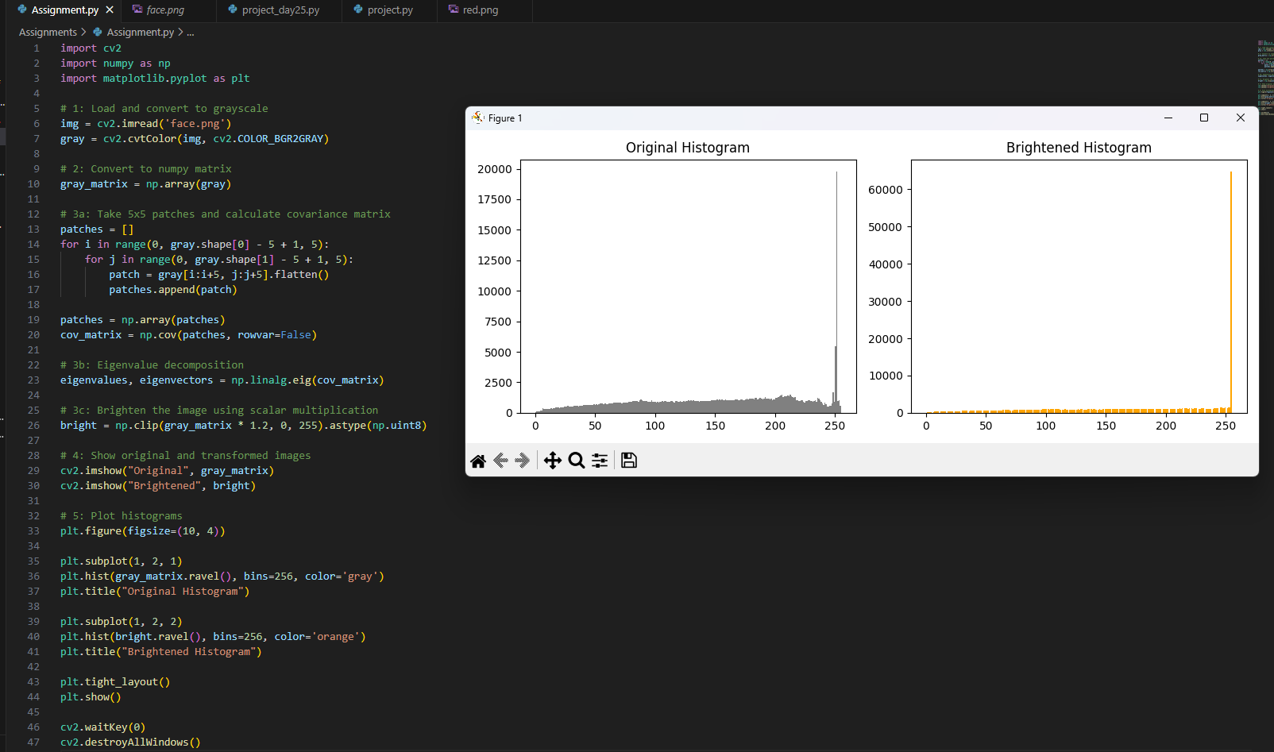

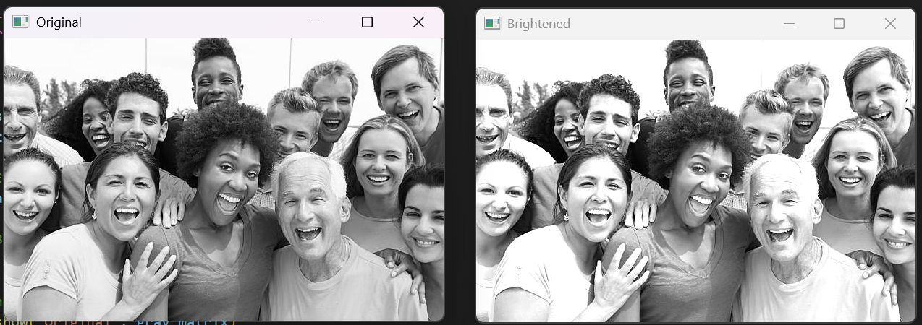

# Question 8: Integrated Project - Image Analysis Pipeline:

Design and implement a complete image analysis pipeline that combines all learned concepts:

8.1 Pipeline Requirements:

1. Input Stage: Load multiple images from a directory
2. Preprocessing Stage:

• Resize all images to a standard size (512 × 512)

• Convert to grayscale

• Apply noise reduction using Gaussian blur

1. Feature Extraction Stage:

• Detect edges using Canny edge detection

• Find faces using Haar cascades (if any)

• Calculate basic image statistics (mean intensity, contrast)

1. Analysis Stage:

• Create a summary matrix containing features from all images

• Use linear algebra operations (matrix multiplication, eigenvalues) to analyze the feature matrix

• Identify the image with the highest edge density

1. Output Stage:

• Generate a report showing results for each image

• Create a collage showing original and processed versions

• Save all intermediate results

8.2 Advanced Requirements:

* Implement the pipeline as a class with modular methods
* Add progress tracking for batch processing
* Include comprehensive error handling
* Generate a statistical summary of the entire batch